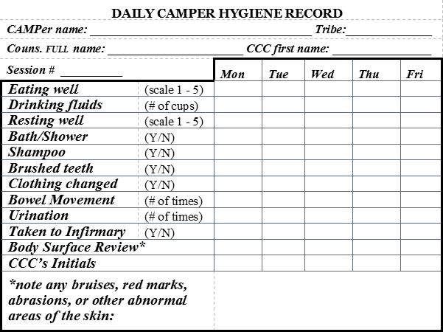
Tips on Filling Out Front of Hygiene Card
Use 1-5 Scale (1= poor; 3= average; 5= wonderful)

- Eating Well: 1-5 Scale
- Drinking Well: # of cups of fluid
- Resting Well: 1-5 Scale
- Bath/Shower: Y/N
- Shampoo: Y/N
- Brushed Teeth: Y/N
- Clothing Changed: Y/N
- Bowel Movement: # of times
- Urination: # of times
- Taken to Infirmary*: Y/N
- CCC’s Initial: Turn in this card each evening to CCC for initialing.
- If you mark a “Y” on “Taken to the Infirmary,” you must explain why at the bottom of the card.

Tips on Filling Out Back of Hygiene Card
This evaluation is important when assessing camper for next year’s session. Please fill out all areas that relate to your camper.
- Note camper mobility
- Note any Direct Care need/hints
- Note Effective Behavior Management Techniques
- Note any other important information
- Note camper: counselor ratio

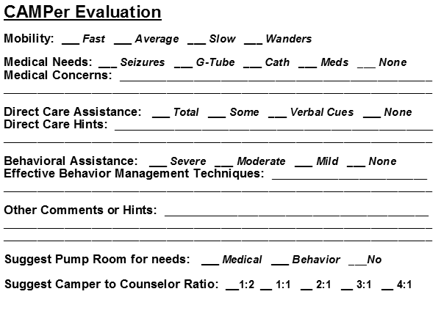

Return Hygiene Card to CCC on Friday.
Do not give this card to the parents!
This is a document that must be kept on file.

